108 Lonsdale Street

Melbourne VIC 3000

Texas Tech University Program Specific Questions for MS Computer Science Course

If you attended an independent campus/affiliated college associated with a university, please list both the name of the campus/college you attended AND the name of the university.* (Please only indicate post-secondary institutions attended; do NOT input secondary school information.)

University: Lovely Professional University (B.Tech – Computer Science and Engineering)

Please input the grading scale of all institutions you attended. You must include the scale in its entirety, including failing/non-passing grades.* (If you attended more than one institution, please enter and label all grading scales.)

|  |  |  |  |  |  |  |
| --- | --- | --- | --- | --- | --- | --- |
| Under-graduation: | | | | | | |
| THEORY | | | PRACTICAL | | |  |
| Grade | Percentage of marks | Grade  points | Grade | Percentage of marks | Grade points |
| AA | 80 ≤ Marks ≤ 100 | 10 | AA | 85 ≤ Marks ≤ 100 | 10 |
| AB | 70 ≤ Marks < 80 | 9 | AB | 80 ≤ Marks < 85 | 9 |
| BB | 60 ≤ Marks < 70 | 8 | BB | 75 ≤ Marks < 80 | 8 |
| BC | 55 ≤ Marks < 60 | 7 | BC | 70 ≤ Marks < 75 | 7 |
| CC | 50 ≤ Marks < 55 | 6 | CC | 65 ≤ Marks <70 | 6 |
| CD | 45 ≤ Marks < 50 | 5 | CD | 60 ≤ Marks < 65 | 5 |
| DD | 40 ≤ Marks < 45 | 4 | DD | 50 ≤ Marks < 60 | 4 |
| FF | 00 ≤ Marks < 40 | 0 | FF | 00 ≤ Marks < 50 | 0 |
| ZZ | Absent in Examination | -- | ZZ | Absent in Examination | -- |
| Theory: AB (9) Practical: BB (8) | | | | | | |

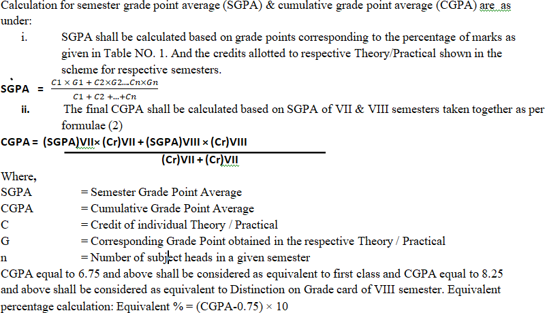

CGPA = ((6.33 * 7.52) +(10 * 7.52)) / (7.52+7.52) = 122.8016 / 15.04 = 8.165

Equivalent % = (8.165 – 0.75) * 10 = 74.15

List post-secondary courses you have completed that correspond to each of the following courses: 1.) Data Structures, 2.) Design and Analysis of Algorithms, 3.) Computer Architecture, and 4.) Operating Systems.* (For each course, list the course name, course number, and semester number in which you completed each course.

)

CSE205: Data Structures and Algorithms - 3rd Semester

CSE211: Computer Organization and Design – 3rd Semester

CSE408: Design and Analysis of Algorithm - 4th Semester

CSE316:Operating Systems - 4th Semester

CSE325: Operating Systems Laboratory – 4th Semester